电机负荷计算书
Calculation Sheet for Motor Load

浙江浙起机械有限公司
Zhejiang Zheqi Machinery Co., Ltd.
一、起升电机负荷计算
I. Calculation of Lifting Motor Load
电动机计算功率:
Calculated power:
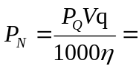
其中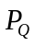为额定起升载荷=18000kg=176400N
Where, is the rated lifting load: =18000kg=176400N
为起升速度 =50m/min=0.833m/s
is the lifting speed: =50m/min=0.833m/s
为机构传动效率 =0.94
is transmission efficiency of the mechanism: =0.94
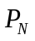= 176400*0.833/1000/0.94=156.3kW
主起升所选择电动机YZPF315M1-4额定功率P_{额}＝160kW (S3-60%)
The motor YZPF315M1-4 selected for main lifting has a rated power of P_{rated}＝160kW (S3-60%)
额定转速n_{额}＝1488r/ min,满足使用要求。
Rated speed: n_{rated}＝1488r/ min, meeting the requirement.
二、运行电机负荷计算
II. Calculation of Motor Load During Operation
（一）小车运行电机负荷计算
(I) Calculation of Motor Load for Trolley Operation
1、电动机计算
1. Calculation of Motor
运行速度V＝55 m/min 车轮直径D＝Φ315 mm
Traveling speed: V＝55 m/min; Wheel diameter: D＝Φ315 mm
小车在直线轨道上稳定运行的静阻力F_{j}由摩擦阻力F_{m}、坡道阻力F_{p}和风阻力F_{w}三项组成(室内使用风阻力忽略不计）
The static resistance F_{j} of the trolley during stable operation on a straight track is composed of the frictional resistance F_{m}, the gradient resistance F_{p}, wind resistance F_{w} (Negligible indoor wind resistance)
F_{j}＝F_{m}+F_{p}+F_{w}＝2184+564.5 ＝2748.5 N
（1）摩擦阻力F_{m}
(1) Frictional resistance F_{m}
起重机满载运行时的最大摩擦阻力：
Max. frictional resistance of the crane during full-load operation:
F_{m} ＝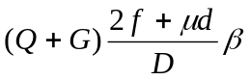 = 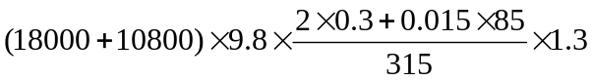＝2184 N
滚动摩擦系数f＝0.3 mm
Coefficient of rolling friction f = 0.3 mm
车轮轴承摩擦系数μ＝0.015
Friction coefficient of wheel bearing μ＝0.015
轴承配合处车轮轴直径 d＝85 mm
Wheel axle diamater at bearing fit d＝85 mm
附加摩擦阻力系数β＝1.3
Additional coefficient of frictional resistance β＝1.3
（2）坡道阻力F_{p}
(2) Gradient resistance F_{p}
F_{p}＝ (Q＋G) i＝ (18000＋10800) ×9.8×0.002＝564.5 N
电动机的静功率 Ｐ_{j}＝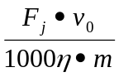＝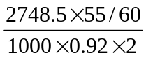＝1.37 kW
Static power of the motor: Ｐ_{j} ＝＝＝1.37 kW
电动机计算功率 P=K_{d}*Ｐ_{j} = 1.4*1.37=1.92kW
Calculated power of the motor: P=K_{d}*Ｐ_{j} = 1.4*1.37=1.92kW
小车运行速度为55m/min时，功率放大系数K_{d}=1.4
When the trolley's traveling speed is 55m/min, the power-amplification ratio: K_{d}=1.4
选择电机型号为100A/4，功率3.0kW，转速1450r/min
The selected motor model: 100A/4, power: 3.0kW, speed: 1450r/min
（二）大车运行电机负荷计算
(II) Calculation of Motor Load for Crane Operation
1、电动机计算
1. Calculation of Motor
运行速度V＝70 m/min 车轮直径 D＝Φ400mm
Traveling speed: V＝70 m/min; Wheel diameter: D＝Φ400mm
大车在直线轨道上稳定运行的静阻力F_{j}由摩擦阻力F_{m}、坡道阻力F_{p}和风阻力F_{w}三项组成(室内使用风阻力忽略不计）
The static resistance F_{j} of the crane during stable operation on a straight track is composed of the frictional resistance F_{m}, the gradient resistance F_{p}, wind resistance F_{w} (Negligible indoor wind resistance)
F_{j}＝F_{m}+F_{p}+F_{w}＝7342.65+1450.4 ＝8793.05 N
（1）摩擦阻力F_{m}
(1) Frictional resistance F_{m}
起重机满载运行时的最大摩擦阻力：
Max. frictional resistance of the crane during full-load operation:
F_{m} ＝ = 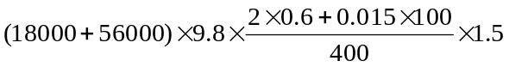＝7342.65 N
滚动摩擦系数f＝0.6 mm
Coefficient of rolling friction f = 0.6 mm
车轮轴承摩擦系数μ＝0.015
Friction coefficient of wheel bearing μ＝0.015
轴承配合处车轮轴直径 d＝100 mm
Wheel axle diamater at bearing fit d＝100 mm
附加摩擦阻力系数β＝1.5
Additional coefficient of frictional resistance β＝1.5
（2）坡道阻力F_{p}
(2) Gradient resistance F_{p}
F_{p} ＝ (Q＋G) i＝ (18000＋56000) ×9.8×0.002＝1450.4 N
电动机的静功率 Ｐ_{j}＝＝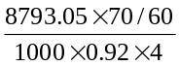＝2.79kW
Static power of the motor: Ｐ_{j} ＝＝＝2.79kW
电动机计算功率 P=K_{d}*Ｐ_{j} = 1.6*2.79=4.464kW
Calculated power of the motor: P=K_{d} *Ｐ_{j} = 1.6*2.79=4.464kW
大车运行速度为70m/min时，功率放大系数K_{d}=1.6
When the crane's traveling speed is 70m/min, the power-amplification ratio: K_{d} =1.6
选择电机型号为132S/4，功率5.5kW，转速1450r/min
The selected motor model: 132S/4, power: 5.5kW, speed: 1450r/min

